# Technical Memorandum/Internal Working Draft 1.05

# Subject: Subject: Population’s Exposures to Pollens in Different Climate Zones in United States

Version: Working Summary Version 1.0

From: Kun Mei

To: Dr. Panos G. Georgopoulos ,YongZhang

Date: Nvo 20, 2013

**1 Introduction**

Airborne allergenic pollen, which has been found to act synergistically with common air pollutants, such as ozone, will cause allergic airway disease (AAD). its distributions exhibit considerable variability in space and time. We can display both the temporal and spatial distributions based on either the mechanism models or statistical models using Matlab. Then we use Monte-Carlo method to predict the exposure effect of the pollen in different areas Finally we using OAT sensitivity analysis to analyse the sensitivity of those physical paremters related to route of the exposure of pollens to human

**2 Methods**

**2.1 model**

**Data Collection**

Observed airborne pollen counts were obtained from monitoring stations of the American Academy of Allergy Asthma and Immunology (AAAAI) located in 9 different climate zones. The reported pollen data were classified only at the level of genus. Species under genus of either Ambrosia,Artemisia,Betula,Gramineae or Quercus were not differentiated.

Data used here are from March to May, which is roughly considered as the flowering season, the spatial distribution of the 1000 hour and 1200 hour of scenario is displayed in figure 1 and 2,using VERDI. We are using logarithm instead of linear to make the figure more clear

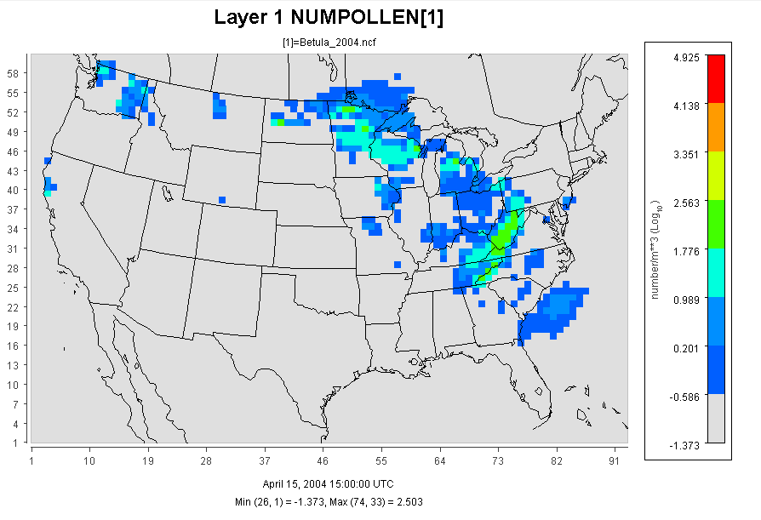

Figure 1 using VERDI pollens(Betula) distribution in early March

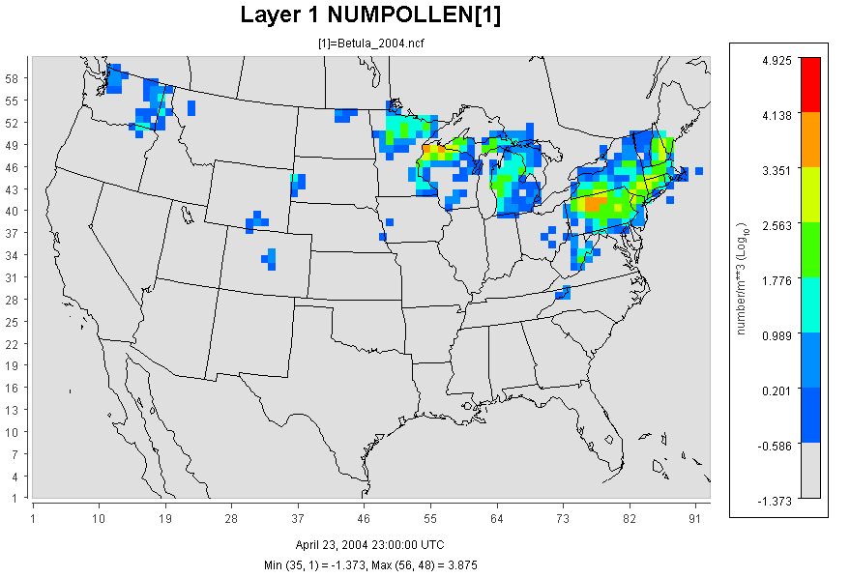

Figure 2 using VERDI pollen(Betula) distribution in late May

**Exposure Method Selection**

**1 Inhalation**

Exposure can be quantified by multiplying the concentration of an agent times the duration of the contact. Exposure can be instantaneous when the contact between an agent and a target occurs at a single point in time and space .The summation of instantaneous exposures over the exposure duration is called the time-integrated exposure (Zartarian et al., 2007). Equation shows the time-integrated exposure.

*E=*

where: E = Time-integrated exposure (mass/volume),

t2– t1 = Exposure duration (ED) (time),

C = Exposure concentration as a function of time (mass/volume).

Dividing the time-integrated exposure by the exposure duration, results in the time-averaged exposure

In this paper, since the time step is 1 hour, we integrated the concentration through the whole flowering season (an average time about 200 hours),and we use numbers of pollen instead of the concentration which would be more reasonable in investigating the effect of pollen.

The Exposure Factors Data are from Exposure Factor Handbook 2011

The Population Data are from U.S Census Bureau: Age and Sex Composition:2010

**2 Dermal Exposure**

Dermal exposure to volatile chemical compound is fully studied already, however, the reports to the dermal exposure to pollen remains rare. We use dry deposition model to estimate the adherence of pollen to human skins.

The dry deposition model assumed that the transport of material to the surface is to be governed by three resistances in series: the aerodynamic resistance

, the quasi-laminar layer resistance , and the surface or canopy resistance .The total resistance, by definition, the inverse of the deposition velocity

For particle dry deposition, becomes

While is the particle settling velocity

Where is the density of the particle, is the particle diameter, g is the gravitational acceleration, μ is the viscosity of air, and is the slip correction factor.

Where Sc is the Schmidt number, St is the Stokes number, and D is the molecular diffusivity,

So the direct deposition to the skin can be calculated now

1 indoor

2 outdoor

Where is the mass of the substance in the skin surface is, is the exposed skin area.

The parameters are ventilation rate and indoor deposition velocity, respectively.

**Sensitivity Analysis**

Sensitivity analysis is the analysis of how the uncertainty in the output of a mathematical system or modeling(numerical or otherwise) can be apportioned to variety sources of uncertainty in its inputs.[1] A similar test is uncertainty analysis, which mainly focus on uncertainty quantification and propagation of uncertainty.

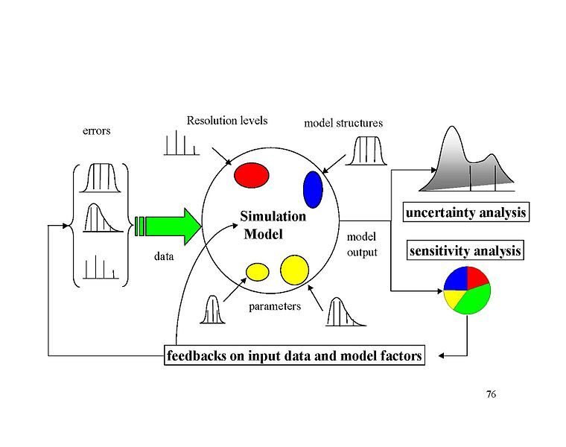

sensitivity analysis,Andrea Saltelli

Mean daily mass intake exposure to pesticide was selected as a metric for testing the system’s sensivity to multiple inputs and parameters.Global sensitivity analysis were performed based on Morri’s Design. This design estimate the main effect of a parameter by computing a number of local sensitivities at random points of the parameter space.The mean of these randomized local sensitivities indicates the overall influence of a given parameter on the output metric,while the corresponding standard deviation indication the effects of interacting and nonlinearity.

In the current study,each of the 17 parameters(Table 1) was sampled 3600 times according to the Morris method from 200 trajectories (each has 18 steps) in the parameter space. Each of the paramters in the simulation was perturbed from 50% to 150% of its base value or its distribution while we keep other parameters unchanged in the same time.

The mean daily exposure for sensitivity analyses was normally generated using 10000 “virual men” in each climate zones in the flowering season.Equation was used to calculate the Normalized Sensitivity Coefficients(NSC) at a local point.

**3 Result and Discussion**

The exposure duration t can be set to different values for assessing exposure associated with different time durations. For example, it can be set to 1 hour to 24 hour to asses hourly to daily exposures.

Figure 2 1-5 Conctration for 5 different kinds of pollens(Ambrosia,Artemisia,Betula,Gramineae,Quercus)

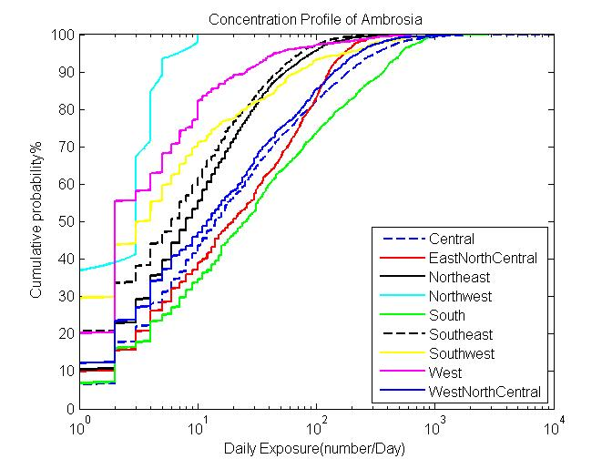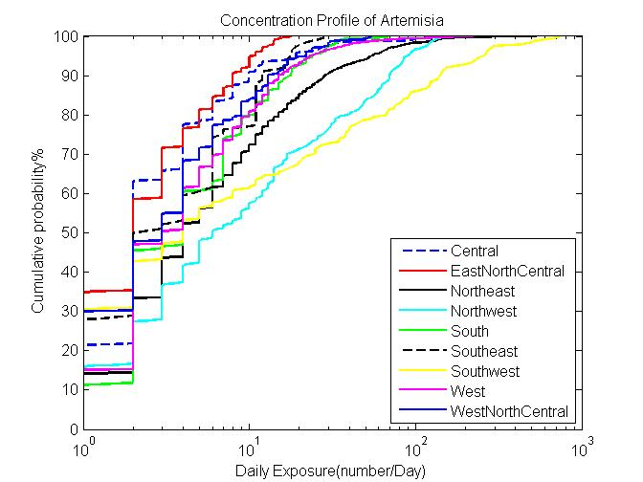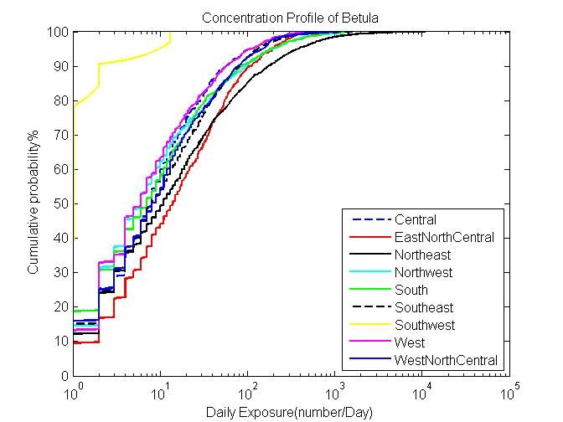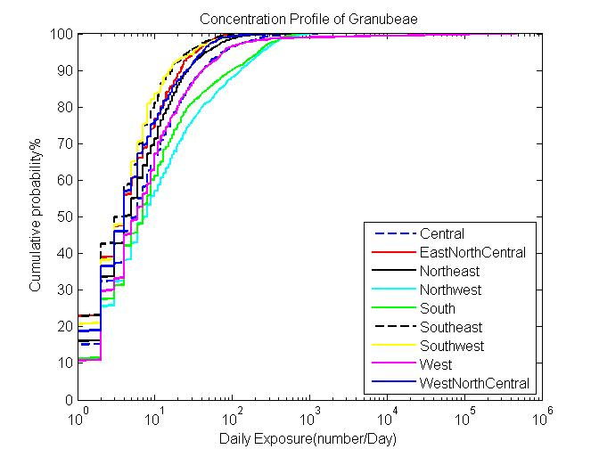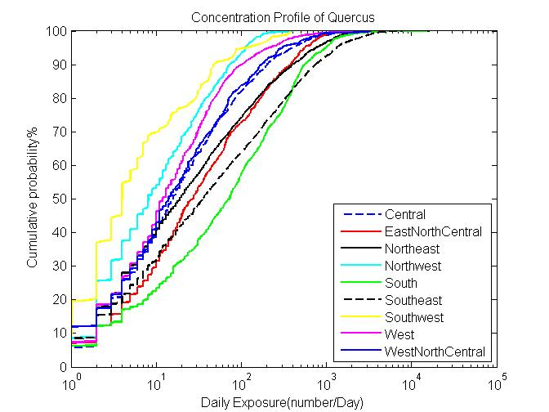

The following figures are the time series of the concentration of pollens in the nine climate zones respectively.In order to show the significance of the concentration,we process the data to show only the concentrations in the flowering seasons( normally from March 5th to May 8th

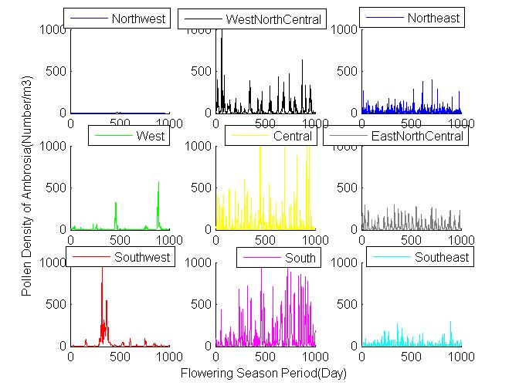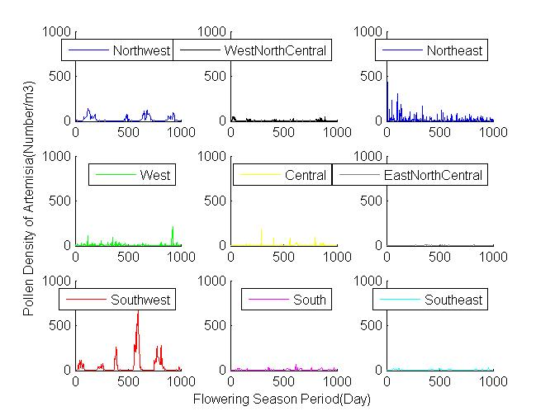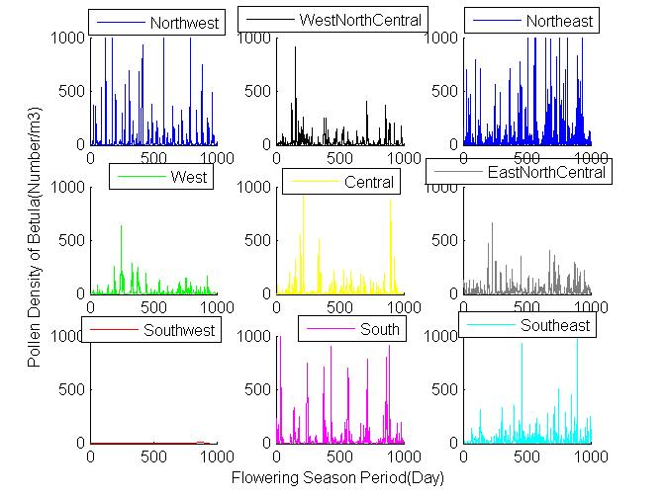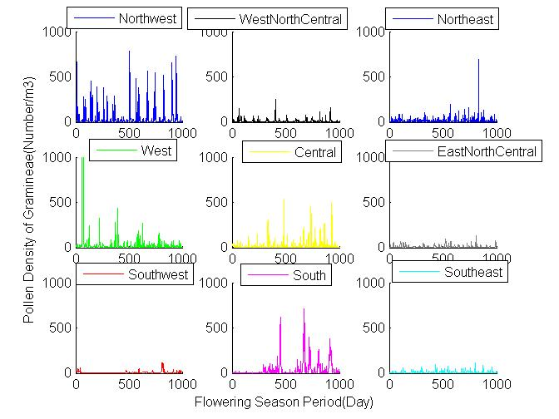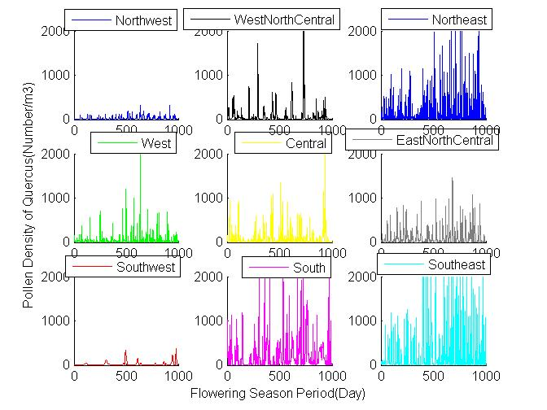

The following figures are the simulated cumulative probability distributions of daily exposures of populations in the 9 nine climates zones to the 5 different kinds of pollens(Ambrosia,Artemisia,Betula,Gramineae,Quercus,respectively)

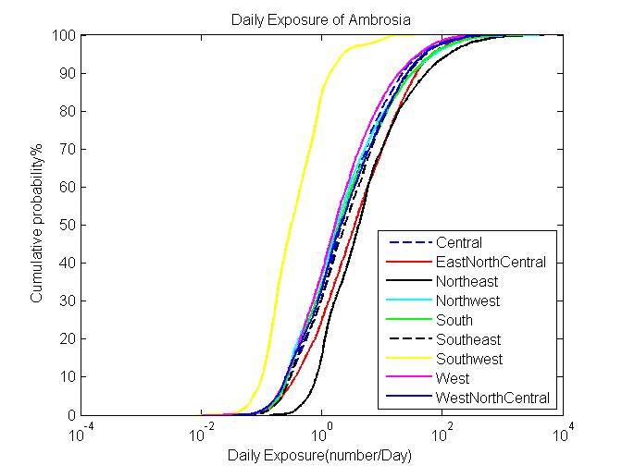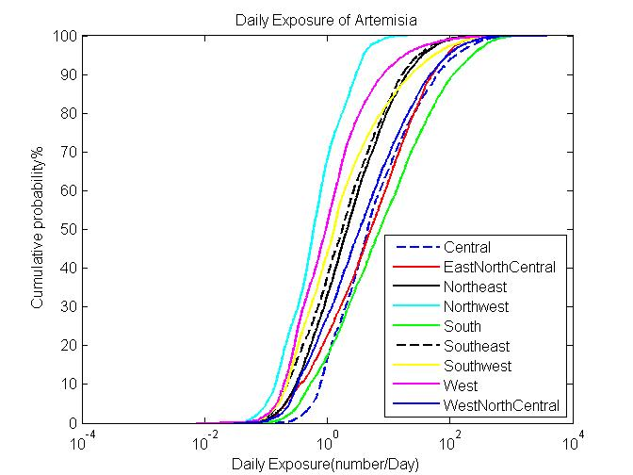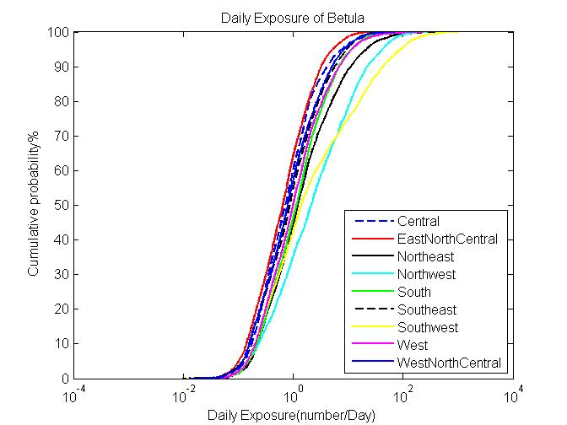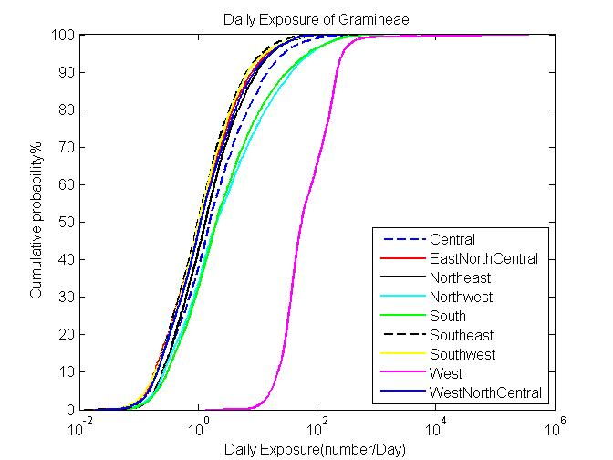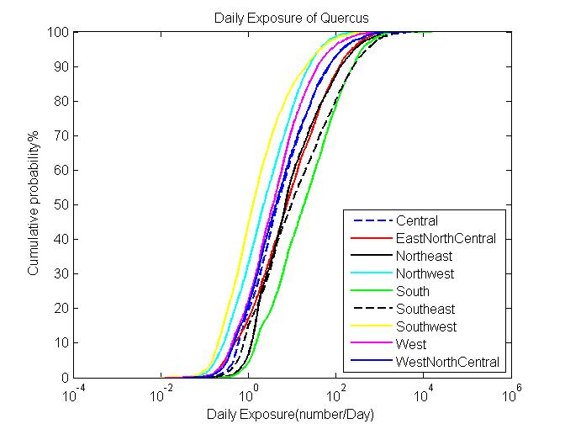

Table S1,Parameters for calculating population exposure to pollens in 9 different climate zones in United States.These parameters were listed either as fixed valueds,known distribtuons or unkown empirical distribution derived from the literatures.

|  |  |  |  |  |  |
| --- | --- | --- | --- | --- | --- |
| **Parameter** | **Parameter ID** | **Distribution** | **Mean(STD)** | **Range** | **Ref.** |
| friction velocity(m/s) | 1 | fix | 1.17 | - |  |
| von karman constant(dimensionless) | 2 | fix | 0.41 | - |  |
| diameter of pollen(m) | 3 | fix | 0.00002 | - |  |
| density of pollen(kg/m3) | 4 | fix | 840 | - |  |
| viscosity of air (m/s) | 5 | fix | 0.0000181 | - |  |
| mean free path of air molecules(m) | 6 | fix | 6.8E-08 | - |  |
| density of air(kg/m3) | 7 | fix | 1.145 | - |  |
| temperature(k) | 8 | range | 298 | 283-310 |  |
| ventilation rate(dimensionless) | 9 | range |  | - |  |
| indoor time(min) | 10 | norm | 1279(21) | - |  |
| outdoor time(min) | 11 | norm | 174(4) | - |  |
| hand to mouth contact frequency | 12 | empirical | 30 | 3-65 |  |
| human surface area(m2) | 13 | lognorm | 1.76 | 0.41-2.51 |  |
| hand surface rate(%) | 14 | lognorm | 5.3 | 4.8-5.6 |  |
| inhalation rate (m3/day) | 15 | uniform | 1.33 | 0.19-1.91 |  |
| inhalation rate(m3/day) | 16 | uniform | 1.45 | 0.20-1.50 |  |
| indoor velidation rate(dimensionless) | 17 | empirical | 1.75 | - |  |

Figure3(1-9) ean and Standard Deviation of Normalized Sensitvity Coefficie

nt(NSC) for population exposure in 9 different climate zones. (A) Inhalation (B)Dermal (C)Total Exposures 1-Central 2

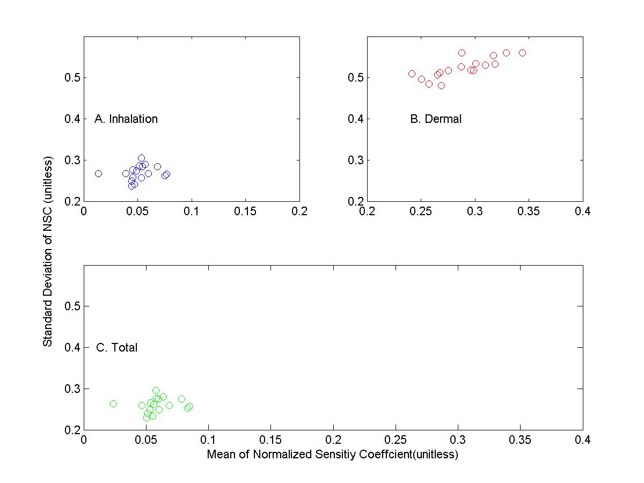

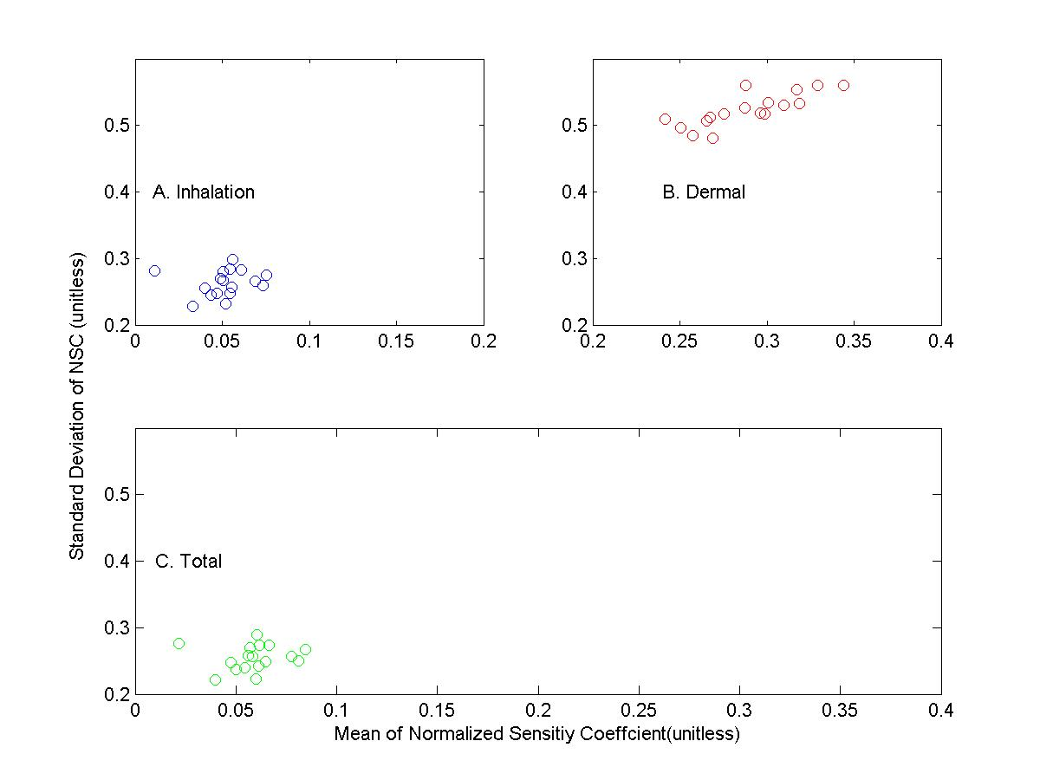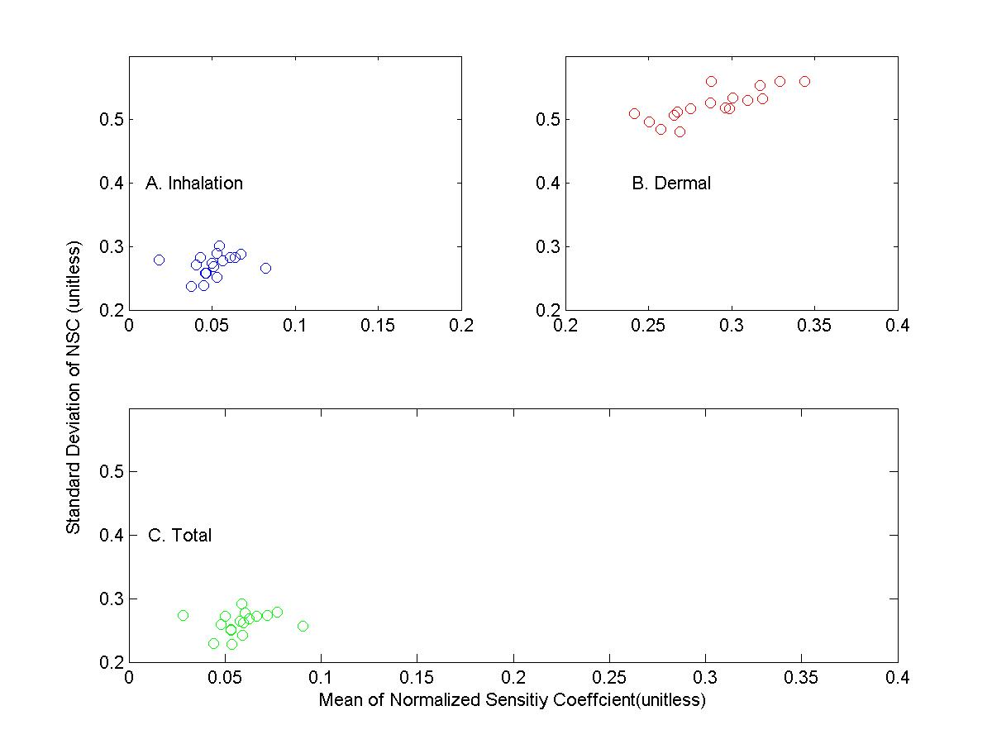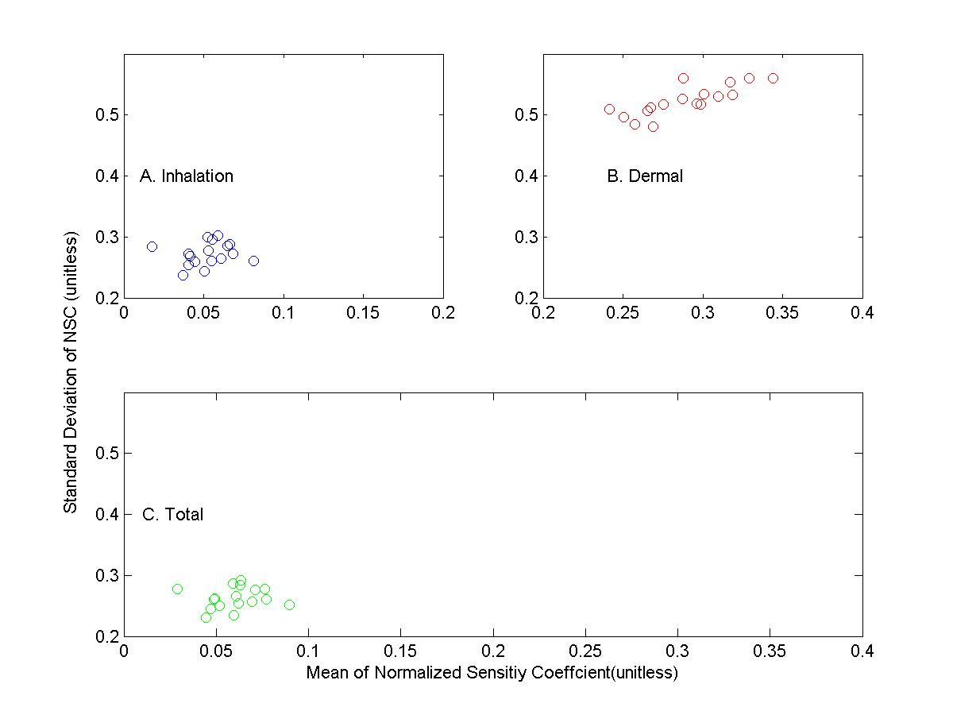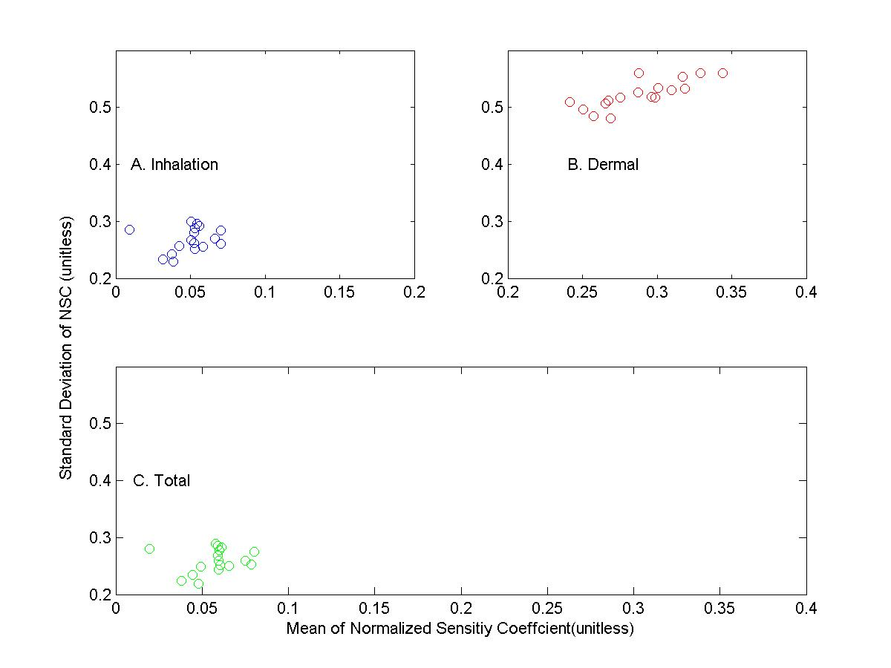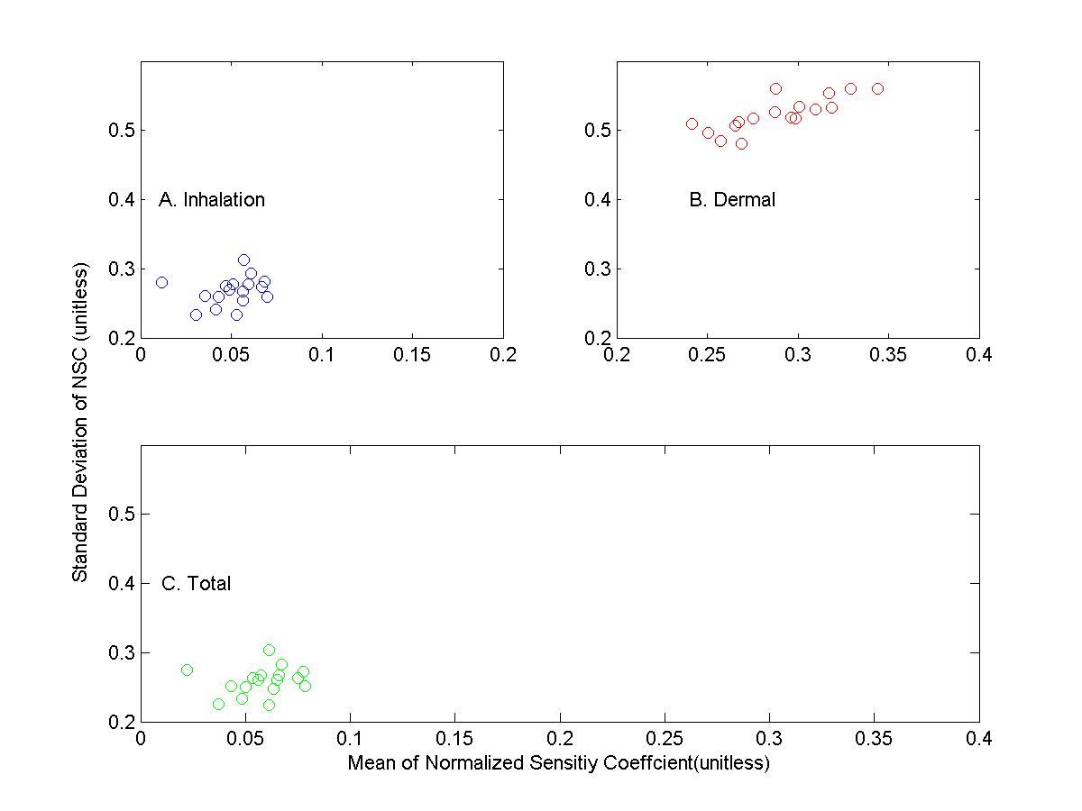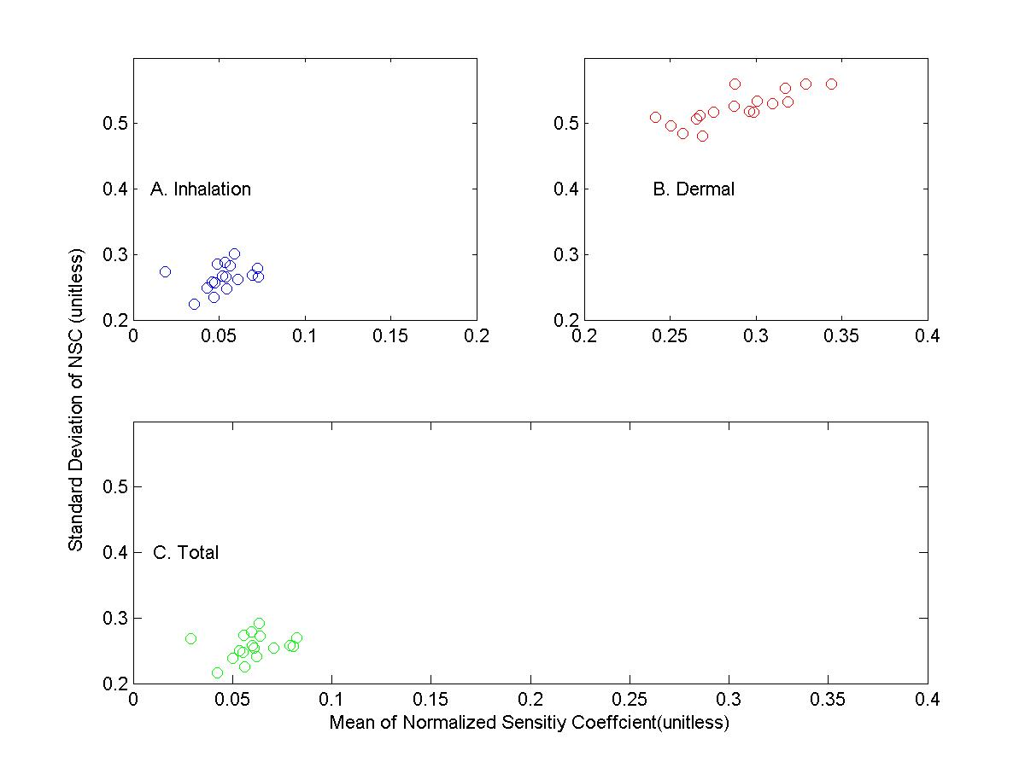 Figure Mean and Standard Deviation of Normalized Sensitvity Coefficient(NSC) for population exposure in the united states( 9 zones combined data) (A) Inhalation (B)Dermal (C)Total Exposures 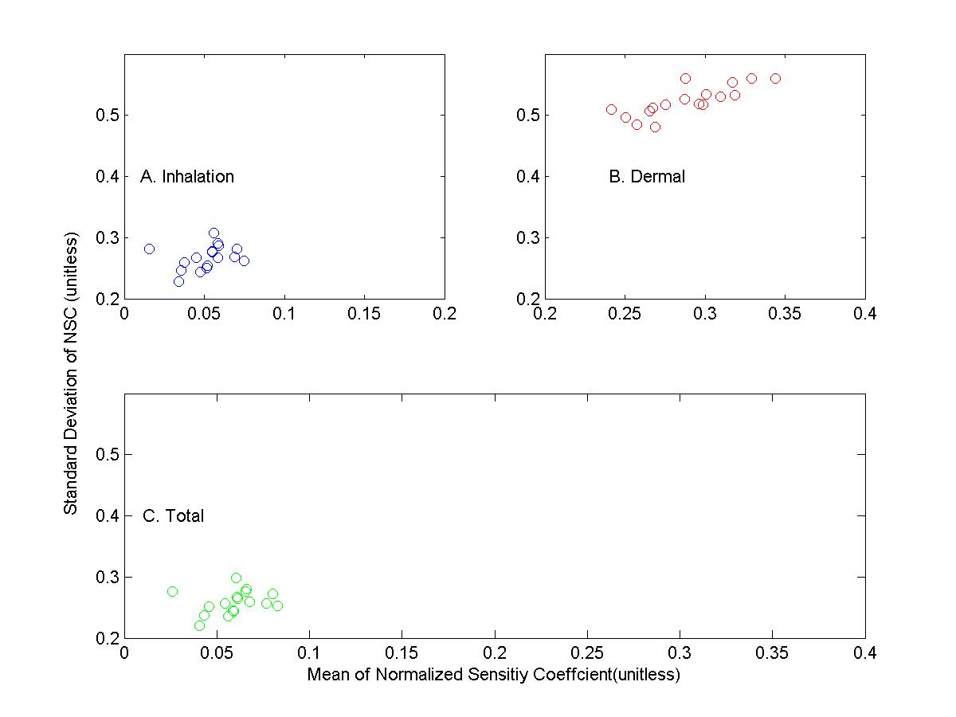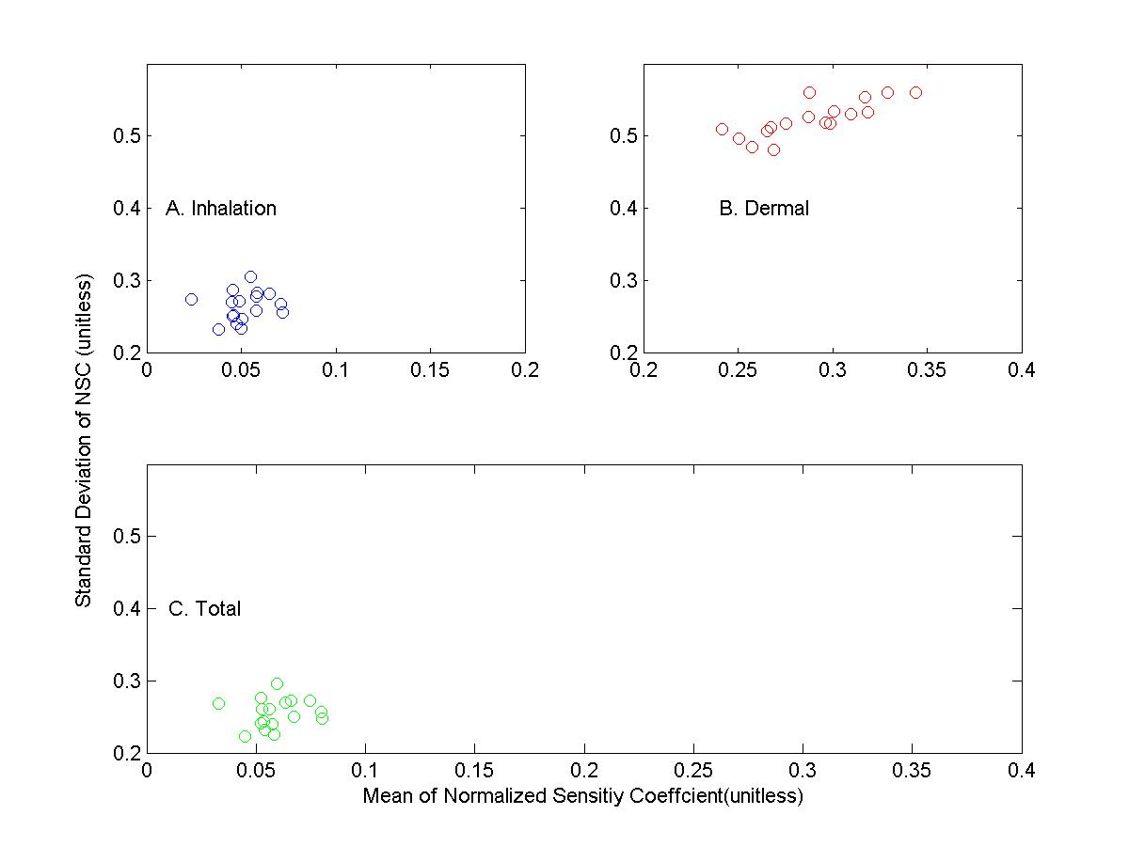

Figure 4 Mean and Stanard deviation of normalized sensitivity coefficient(NSC) in 9 different climate zones based on glabar sensitivity anylses using Morris’s design

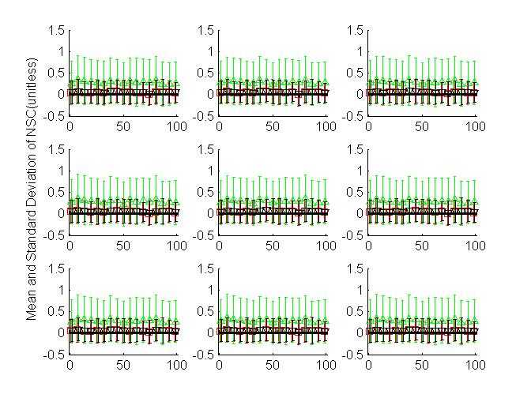

Figure S1

Schematic diagram of modeling occupational exposure of population exposure to pollens in 9 climate zones.Concernrations and surface loading of pollens were simulated based on mass balance and sourece concerntraion from fluid dynamic model.Exposures to pollens were simulated based on the concentration profiles and activity data of different groups by ages and sex from United States Census Bureau.The intake dosed calculated from exposure modeling are then used as input to conduct sensiti vity analysis.



# Conclusion

The modeling system developed based on physical processes and human activity data in the current study,can be easily adapted to simulated risks and exposure to particulate matter(PM) in similar environments or small scaled units such as cities or certain census.Furthermore,sensitivity analyses of the modeling system provides helpful information for planning measurements related to investigation of health risks associated with occupational exposures to pollens or other kinds or particulate particles in the environments.

## Reference

Beamer, P., et al. (2008). "Developing probability distributions for transfer efficiencies for dermal exposure." Journal of Exposure Science and Environmental Epidemiology **19**(3): 274-283.

Bureau, U. S. C. (2010). Profile of General Population and Housing Characteristics: 2010 Census Summary File.

EPA, U. S. (2011). Exposure Factors Handbook. U. S. E. P. Agency.

Fogh, C. L. and K. G. Andersson (2000). "Modelling of skin exposure from distributed sources." Annals of Occupational Hygiene **44**(7): 529-532.

Hu, X., et al. (2011). "Bioaccessibility and health risk of arsenic, mercury and other metals in urban street dusts from a mega-city, Nanjing, China." Environmental Pollution **159**(5): 1215-1221.

National Allergy Bureau, A. (2010). NAB Pollen Counts.

Saltelli, A. C., K;Scott,E.M (2000). Sensitivity Analysis, Wiley Series in Probability and Statistics.

Zhang, Y., et al. (2013). "Modeling Flight Attendants’ Exposures to Pesticide in Disinsected Aircraft Cabins." Environmental Science & Technology.